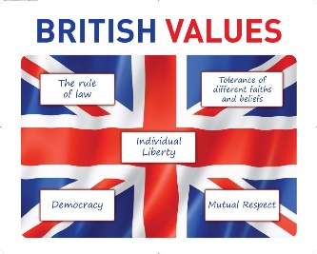
British Values Day
Year 6 Lesson plan
Theme: Individual Liberty

Session 1
Starter:
Q How many different words (using a thesaurus) can you find that relate to the word “liberty?”
Q What does liberty mean to you?
Q Does liberty mean you can do whatever you want?
Main task:
https://equaliteach.co.uk/downloads/Individual-Liberty.pdf
Discuss the statements on page 4
Record a selection of children’s ideas on post-its and add to the poster below
Session 2
Children to research the following British pioneers of individual liberty in small groups. Report back to each other. Please display a picture of the person on the IWB and take a photo of the kids giving their presentation.
Emmeline Pankhurst
https://www.activityvillage.co.uk/emmeline-pankhurst
https://www.bbc.co.uk/bitesize/topics/zd8fv9q/articles/zh7kdxs
Marcus Rashford
https://endchildfoodpoverty.org/
https://www.foodfoundation.org.uk/
https://www.bbc.co.uk/sport/football/55338104
Dame Kelly Holmes
https://news.sky.com/story/olympic-champion-dame-kelly-holmes-announces-she-is-gay-and-kept-it-hidden-for-34-years-12636524 (a shorter article, more suitable for less able readers)
https://www.bbc.co.uk/news/uk-61854980
William Wilberforce
https://www.bbc.co.uk/bitesize/guides/z3rj7ty/revision/8
https://www.historyforkids.net/william-wilberforce.html?utm_content=cmp-true

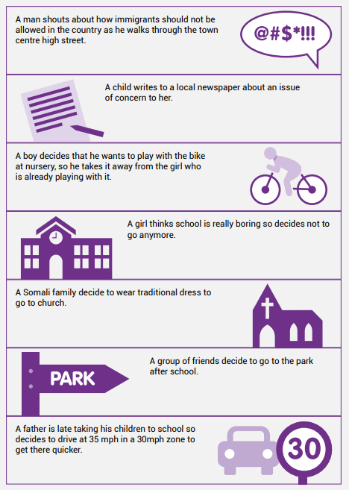

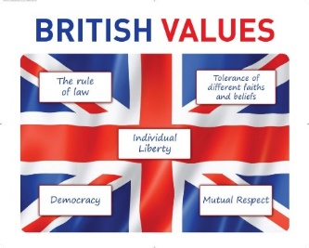

British Values Day
Year 5 Lesson plan
Theme: Democracy

Session 1
Starter:
Q: What is democracy? Can you think of any examples within our school? (Steer the children towards pupil voice!)

Main activity:
Show the following clip about voting and the electoral process https://www.youtube.com/watch?v=ZN0qP0vRqVE
Debate: Should children be allowed to vote?
Groups then write a campaign speech to become the next Prime Minister. Use the template attached.

Session 2
Children deliver their campaign speeches and the class take a final vote on the next Prime Minister!
Please take videos on an IPAD and we will upload these to our website.

The name of your political party | How will you improve wages for all?
How will fix education in our country? | How will you make this country “fair?”
How will you fix the environment? | How will you pay for all of this?

British Values Day
Year 4 Lesson plan
Theme: Tolerance of faiths and beliefs

Session 1
Starter:
Show the Mutual Respect Service (BBC assembly) https://www.bbc.co.uk/programmes/articles/3wWbcGrYq210xzVjF9gHnqv/british-values-mutual-respect

Main activity:
Q: What does tolerance mean?
Q: Where do we show tolerance in the home, at school, in our community, with ourselves, with each other?
Create a list of examples of tolerance
Revise the six main faiths in the UK using https://www.bbc.co.uk/bitesize/subjects/z7hs34j
Give children a wheel with 6 sections. They work in groups to write one fact in each section about each faith.

Session 2
Use the symbols for each faith. Give each child a jigsaw piece to decorate with one of the symbols using the colours of the British Flag.
Put the pieces together at the end to emphasize that we have different beliefs and faiths but we are all one nation.

British Values Day
Year 3 Lesson plan
Theme: Rule of Law

Session 1
Round robin
On each table, have A3 with the words rules of the road, rules at home, rules in school, laws of our country. Rotate the papers and each group records their initial ideas in a certain colour.
Teacher then takes feedback from each group to create a list on IWB “Who helps us stick to the rules”
Show the powerpoint
Children choose a rule maker for their piece of art in the next session.

Session 2
Children to work in groups or pairs to create pictures of people who help us stick to the rules. (Police officers, traffic wardens, teachers, security guards, parents etc)

British Values Day
Years 1 and 2 Lesson plan
Theme: Mutual Respect

Session 1
Starter:
Invite two children to the front and give a fake football commentary “here they are, the two teams coming out to do battle with each other for the league cup, etc etc.” They then shake hands before the match.
Q: Why are sports people encouraged to do this before competing?

Show the Mutual Respect Service (BBC assembly) Video clip https://www.bbc.co.uk/programmes/articles/3wWbcGrYq210xzVjF9gHnqv/british-values-mutual-respect
Discuss:
Q: what is it easy to show respect?
Q: when is it hard to show respect?
Q: what do you need to do to show respect?
Q: what is self respect?
Q: do you have to earn respect?
Q: how could you earn respect and how might you lose it?
Session 2
We can show mutual respect in school by being the best friends we can be.
Go through the powerpoint “How to be a good friend” (TDrive – Personal Development – British Whole School Learning Day)
Play the game where the class sits in a circle. Choose a child at random to go in the centre. Take turns to pay the chid a compliment using the sentence starter “name I like you because….”
Children must have good eye contact whilst listening and speaking – explain that this shows sincerity. Everyone must have a turn – adults too. TAKE PHOTOS PLEASE FOR WEBSITE.
Finish the session by enjoying the story “Ally the Accepting Alligator”
https://www.youtube.com/watch?v=8mmhJzisXOs
Filler if needed: Colour in the dolls with linked hands. On the back, write what it takes to be a good friend.



British Values Day
EYFS Lesson plan
Theme: Mutual Respect

Session 1
Starter:
We are all special and unique.
Q: How are we the same?
Q: How are we different?
You could try “stand up if you have a brother, swap places if you like football, jump twice if you have blue eyes”
Even though we are all different, we must treat each other in a friendly way. This is called respect.
Listen to the story “Ally the Accepting Alligator”
https://www.youtube.com/watch?v=8mmhJzisXOs
Q: should we be friendly to everybody even though we are all different

Session 2
Children paint their hands in red, white and blue stripes. Make a print and cut out when dry. PLEASE TAKE A PHOTO FOR WEBSITE.
Adults record pairs of children on IPADS. Ask “Can you show me how to be a good friend to each other?” Children say or act this out.

